Jagenstadt German Shepherds, Inc.

Here's a list of items to purchase and some tips to get started

Check the General Care page on my website, lots of good info. http://vonjagenstadt.com/care.html
The puppies will have their health certificate from my vet confirming they are healthy and free of parasites.
They will have their 1st set of inoculations (types listed on their health certificates).
They will be micro chipped for identification (chip number will be provided).
You should visit your vet within (48) hours of getting your puppy home to confirm that your puppy is in good health, bring their health certificate with you.
Your vet will set up an appointment with you do additional vaccines, I suggest that you follow the protocol that your vet suggests, vaccine types and schedule may vary depending on the region that you live in.
* I strongly recommend that you wait until your puppy is 6 months old before vaccinating for rabies, give their systems time to deal with all the other vaccines that they will be getting.

Food (Updated 05-01-21)
The puppies have been eating Royal Canin® Breed Health Nutrition™ German Shepherd Kibble Puppy Food, I suggest you continue feeding this food until they are 6 months old, then switch to Royal Canin German Shepherd Kibble Adult Food.
*You should feed the puppy ½ a cup of kibble 3x's a day (gradually increase food as needed) along with 1/3 a can of Chicken, Beef-Chop Meat, Sardines, Royal Canin Starter Puppy Mousse, These added food sources should be alternated on a daily basis, 1 can divided in 3 feedings for the day.

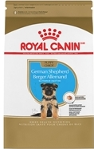

Supplements
*Here is a picture of all the additional food and supplements that I recommend adding to your puppies food.
Start your puppy on Vanilla or Plain Whole Milk Greek Yogurt immediately, (1) T-spoon every other day, alternate days with Herbsmith Microflora Plus.
Wild Alaskan Salmon Oil (1) T-spoon once a day.
It is VERY important to use NuJoint DS (wafer) and NuVet Plus Vitamin Supplement (powder) for the first 12 months of age. This supplement needs to be purchased through their website. www.nuvet.com or by calling (800) 474-7044, you MUST use the order code #:19362, by doing so will keep a record of your order for Breeder to review. Failure to give this supplement to said dog, or to use the code provided when ordering will result in the hip guarantee being null and void.

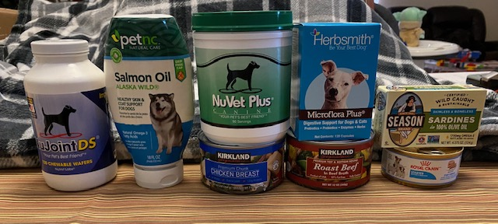

Heart Guard Plus: Start at 10 weeks of age.

Treats
Frozen Carrots
Bully Sticks (in moderation, 1x a week)
RAW beef marrow bones (Do Not Cook) give frozen, you can find them in the meat department at your grocery store, they are usually cut in hockey puck size.
Give (1) a week, they will eat the marrow out of the bone in a day or so, wash and re-fill with peanut butter or the squirt cheese in a can and then freeze.
Throw out after a week or so and start again with a frozen marrow bone, be careful not to give to much marrow it will give them mushy poop.
It's very import that they have a bone to chew on while they are teething, it will also strengthen their jaw muscles which in turn will help their ears to go up strong.
* Thin slices of raw hot dogs are good treats for training but try to keep it to a minimum.
* Help your Puppy to avoid upset stomachs
NO milk bones or commercial treats.
NO Rawhide or pigs ears.
NO Table Food or left overs.
NO Drastic Changes in Diet

Crate for potty training
MIDWEST Lifestages Metal Dog Crate with Divider Panel
Large 42 x 28 x 31 H
* Adjust the space in the crate according to the puppies’ size. They should have room to stand, lay down and turn around. If you give them to much space they will pee or poop in the crate as long as they don't have to lay in it. Adjust the space in the crate as they grow, they should be completely crate trained by 12 weeks of age. Remember, their bladders are not fully developed as a young puppy so be sure to cut their water off by about 6 PM and walk them before going to bed (11:00 PM or so).
You should keep their crate close by so you can hear them should they start to cry in the middle of the night. Don't take them out if they are crying because they are in the crate, let them cry, they will eventually quite down and settle in
for the night, the 3-4 AM cry is usually the one you need to pay attention to. Take them out to go potty and praise them when they do their business. They should be able to get through the night in a week or two.

Toys
Nyla Bones are good, Kongs are good, Cuz' are good....all durable toys.

Grooming
A Rake and a Medium Stainless Steel Comb are all you need.
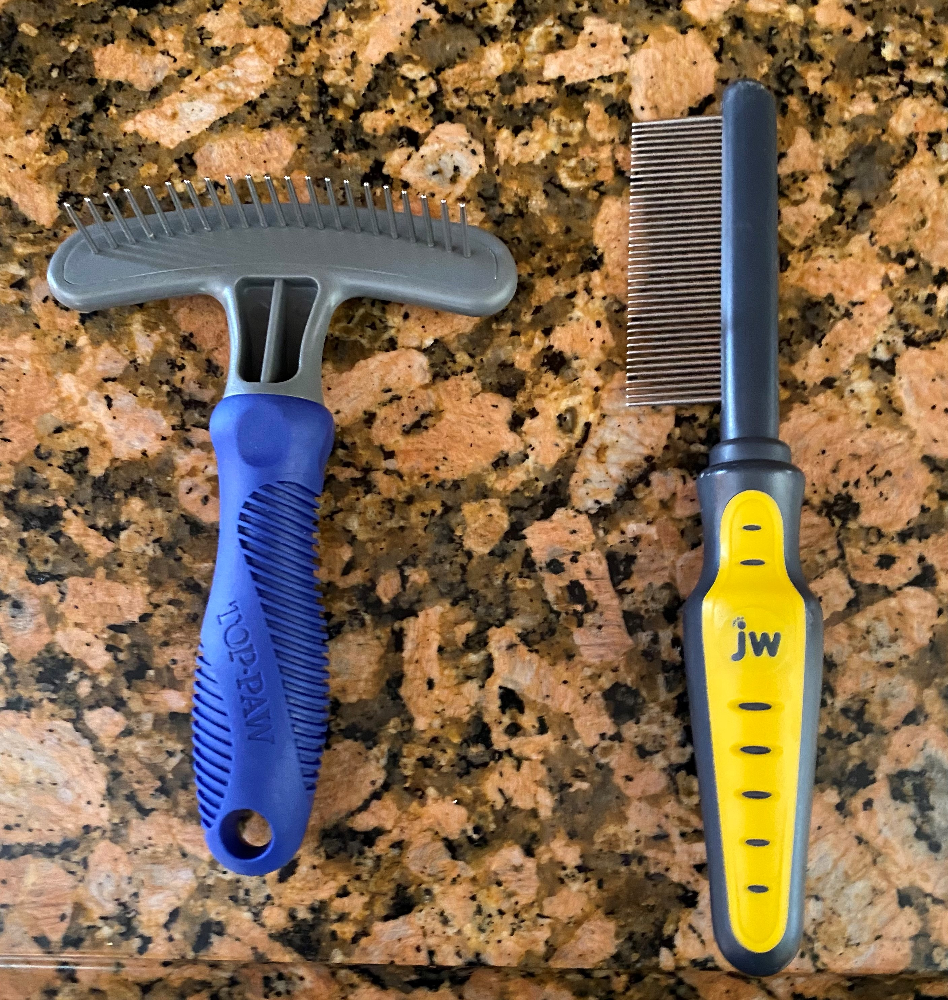
Supplements
*Here is a picture of all the additional food and supplements that I recommend adding to your puppies food.
Start your puppy on Vanilla or Plain Whole Milk Greek Yogurt immediately, (1) T-spoon every other day, alternate days with Herbsmith Microflora Plus.
Wild Alaskan Salmon Oil (1) T-spoon once a day.
It is VERY important to use NuJoint DS (wafer) and NuVet Plus Vitamin Supplement (powder) for the first 12 months of age. This supplement needs to be purchased through their website. www.nuvet.com or by calling (800) 474-7044, you MUST use the order code #:19362, by doing so will keep a record of your order for Breeder to review. Failure to give this supplement to said dog, or to use the code provided when ordering will result in the hip guarantee being null and void.

* Bathe no more then 4-5 times a year (use an oatmeal shampoo with aloe).
You do not want to take the oils out of your dog’s skin, over bathing will do this.
If your dog gets some mud or dirt on them just rinse them off with fresh water, no shampoo or soap is necessary

Book/Reference: The Total German Shepherd Dog by Fred Lanting
This is a great reference book that covers many subjects, a good book to have over the years.

